Self-assigning iRIS training in myLearning
1. Login to ONE Digital Workplace
2. Click on My Learning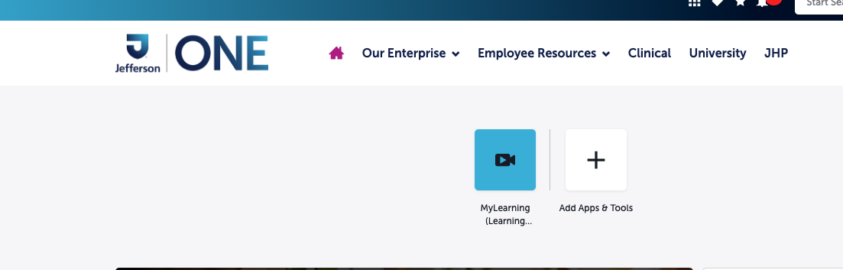
3. Click View My Learning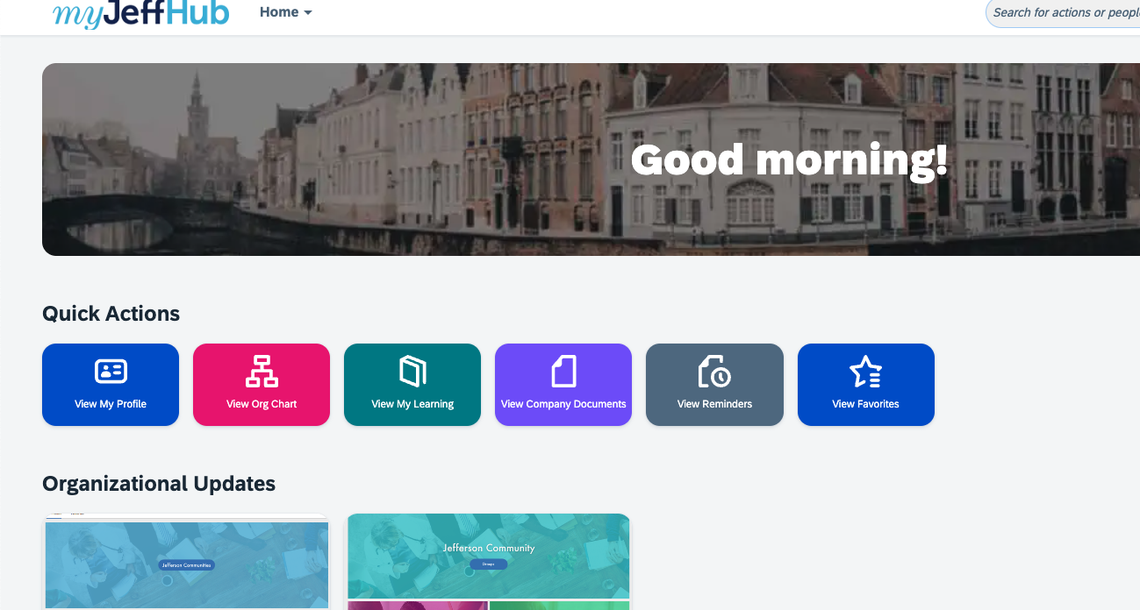
4. Under Find Learning, search iRIS e-IRB Training
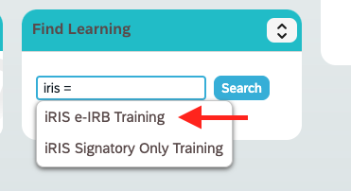

**Very Important** In order to have full access to iRIS you must complete the course AND the survey. Once you complete the course, the survey will be in your overdue section.

Once you complete both the Training and Survey in MyJeffHub, you will receive access within 24-48 hours.

