Self-assigning iRIS training in myLearning

1.    Login to [MyJeffHub Learning Portal](https://nam10.safelinks.protection.outlook.com/?url=https%3A%2F%2Fjam8.sapjam.com%2Fgroups%2Fndbcst5T4ucNf9wRUVHsYO%2Foverview_page%2Fdo3SUDq3pPDdVbweQVCdZD&data=05%7C01%7CKyle.Conner%40jefferson.edu%7C14559bbe01f74777dc7208da9fdee2fa%7C55a89906c710436bbc444c590cb67c4a%7C0%7C0%7C637998076884779698%7CUnknown%7CTWFpbGZsb3d8eyJWIjoiMC4wLjAwMDAiLCJQIjoiV2luMzIiLCJBTiI6Ik1haWwiLCJXVCI6Mn0%3D%7C3000%7C%7C%7C&sdata=e3g%2FSgpg%2FRPox3Cbjti%2Fyf0kH63fpoLtAHJa2VCRkdU%3D&reserved=0)

2.    Click on “My Assigned Learning”

3.    Under Find Learning, type in  “iRIS e-IRB training” and you can assign the course to yourself which can be found under Due Later

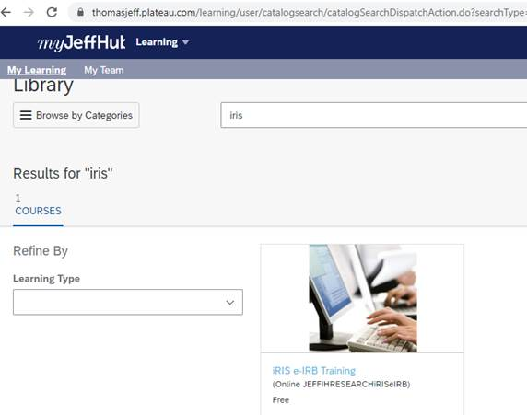

**\*\*Very Important\*\*** In order to have full access to iRIS you **must complete the course AND the survey**. Once you complete the course, the survey will be in your **overdue** section.

Once you complete both the Training and Survey in MyJeffHub, you will receive access within 24-48 hours.