Metabolomics Core
Mission: Our facility measures metabolites in human and rodent tissues and body fluids (serum) and can also assist clinicians and basic science researchers in the design and interpretation of metabolomics results.
Goals: To provide a state-of-art facility metabolomics research.
Capabilities:
- Targeted metabolomics – We perform targeted metabolomics, which refers to the analysis of defined subsets of molecules (molecular weight less than 1500 Daltons).

- Fluxomics – This involves approaches that seek to determine the rates of metabolic reactions within a biological entity. Specifically, we perform isotope-labeling studies to measure the flow of atoms through metabolic pathways, such as glycolysis, the tricarboxylic acid cycle, beta-oxidation and the urea cycle.

- Assays for measuring mitochondrial oxygen consumption and glycolytic rates using Seahorse Bioanalyzer.

Major Equipment:
ACQUITY UPLC System with Xevo TQ-S Mass Spectrometer
Seahorse XFp Analyzer
Workflow:
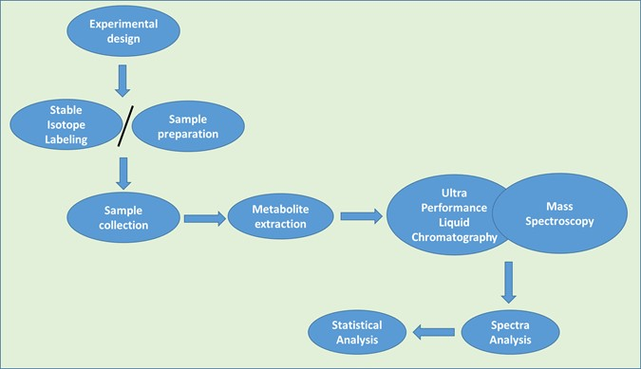
Detailed services:

Metabolites measured:
Glycolysis intermediates |  | Pentose pathway intermediates | TCA Cycle intermediates
- Glucose  - Glucose 6-phosphate  - Fructose 6-phosphate  - Fructose 1,6-bisphosphate  - Dihydroxyacetone phosphate  - Glyceraldehyde 3-phosphate  - 1,3-Bisphosphoglycerate  - 3-Phosphoglycerate  - 2-Phosphoglycerate  - Phosphoenolpyruvate  - Pyruvate  - Lactate |  | - 6-phosphoglucono-δ-lactone  - 6-phosphogluconate  - ribulose 5-phosphate  - ribose 5-phosphate  - xylulose 5-phosphate  - sedoheptulose 7-phosphate  - erythrose 4-phosphate | - Acetyl CoA  - Oxaloacetate  - Citrate  - cis-Aconitate  - Isocitrate  - Oxalosuccinate  - α-Ketoglutarate  - Succinyl-CoA  - Succinate  - Fumarate  - Malate
Amino acids (Amino compounds) |  | Urea Cycle intermediates | Nucleotide
- alanine  - arginine  - asparagine  - aspartic acid  - cysteine  - glutamine  - glutamic acid  - glycine  - histidine  - isoleucine  - leucine  - lysine  - methionine  - phenylalanine  - proline  - serine  - threonine  - tryptophan  - tyrosine  - valine | - α-Aminoadipic acid  - Hydroxyproline  - Ethanolamine  - β-Aminoisobutyric acid  - 1-Methylhistidine  - 3-Methylhistidine  - Hydroxylysine  - Sarcosine  - Phosphoethanolamine  - Citrulline  - α-Amino-n-butyric acid  - allo-Isoleucine  - Ornithine  - Carnosine  - β-Alanine  - Taurine  - Cystathionine  - Anserine  - γ-Amino-n-butyric acid | - carbamoyl phosphate  - citrulline  - ornithine  - aspartate  - argininosuccinate.  - Arginine  - Fumarate  - urea | adenine  cytosine  guanine  thymine  uracil  purine  pyrimidine
- Fatty acyls (Fatty acids)  - glycerolipids  - glycerophospholipids  - sphingolipids  - sterols |  | FADH2  NAD+  NADH  NADP+  NADPH  adenine nucleotides (AMP, ADP, ATP)  Guanosine triphosphate (GTP)

Please contact us for more information on the types of isotope labeling studies performed and for information on consulting serves.
Note: We do not accept samples that were exposed to radioactive or infectious materials.

Contact: Hoora Shaghaghi, PhD. Hoora.Shaghaghi@jefferson.edu Phone 215-503-0444

